Alan Tsai

CS281

When main() is called, the stack frame is created with enough space for the variables that are in the main

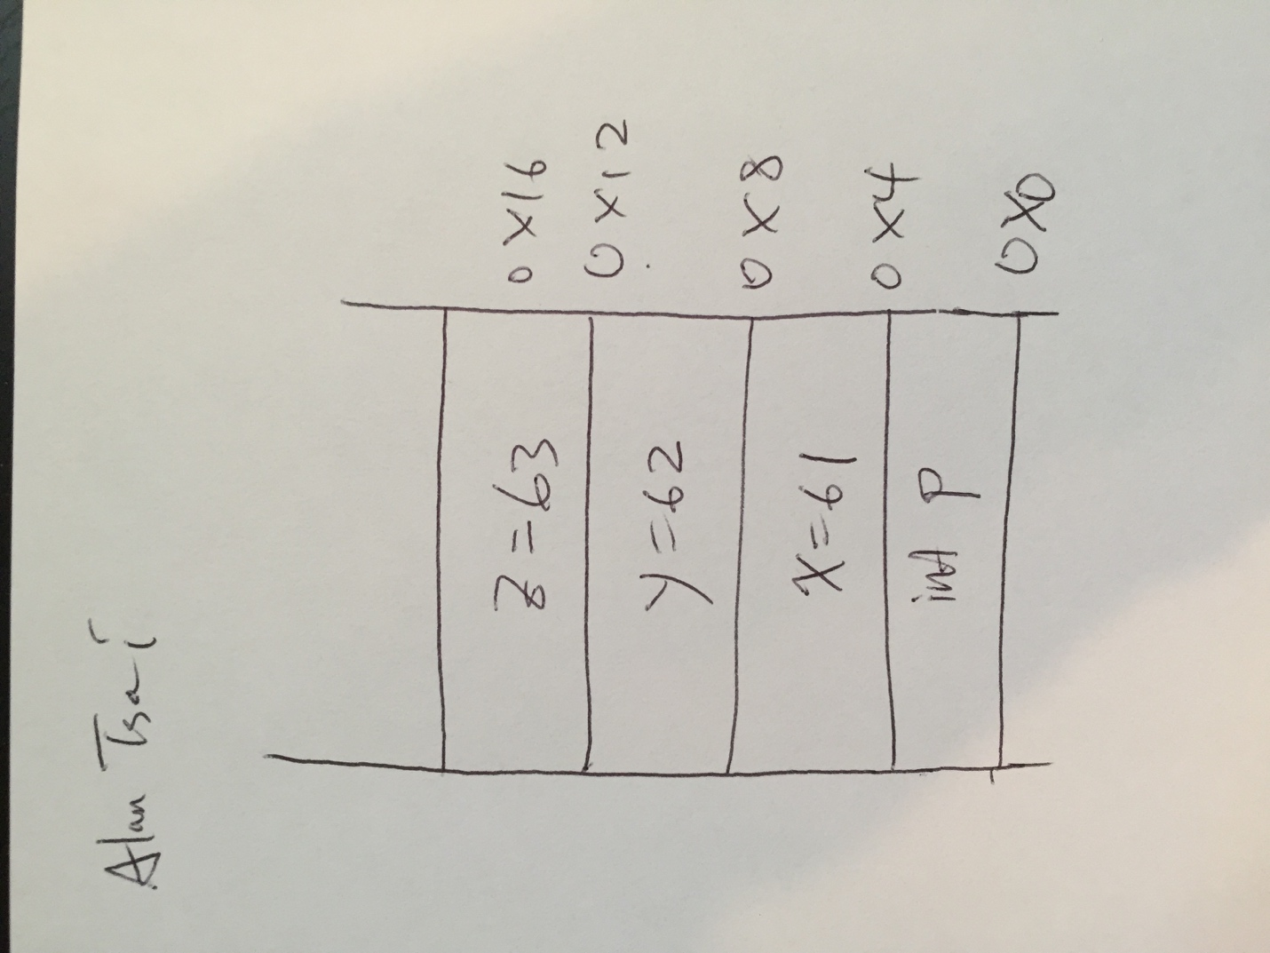

But in order to get a value for p, we must execute the method test(x). In order to prepare for test to be called, main must place some overhead on the stack then it must push any parameters necessary for foo on the stack. So when “test” is called it begins execution with the following execution stack.

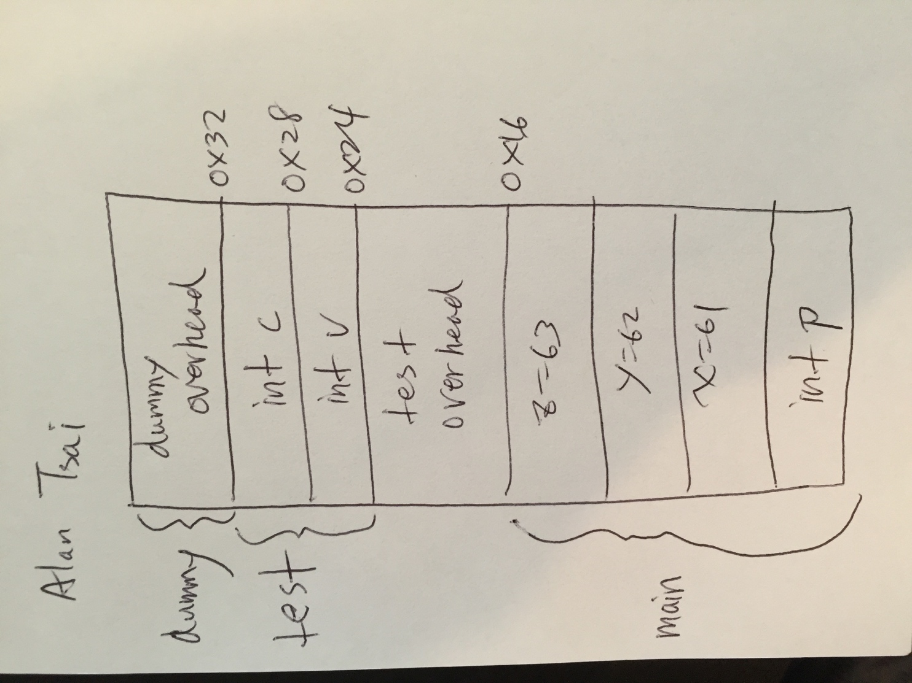

Notice that in order to attain the value of p, test must blindly reach up and assume that main put the correct argument on the stack.

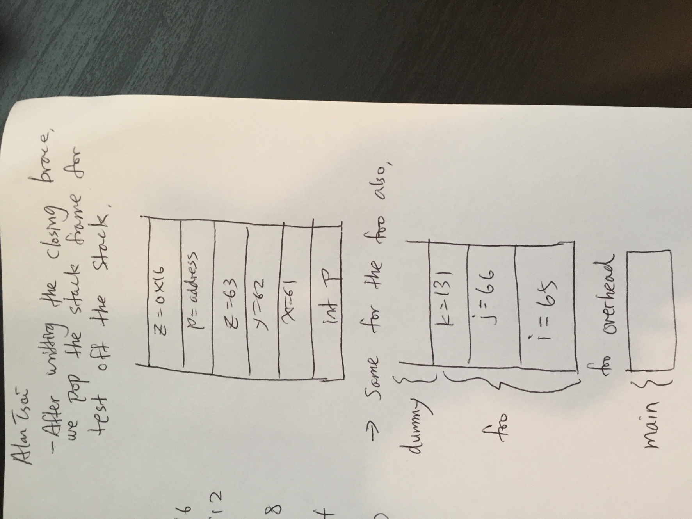

Here, z=\*p -> z gets the value point to by p. \*p=70 -> set whatever p points to 70. Again, the \* tells us to go to the location pointed to by p.

